Call for Industry/Project session

ISGT Europe 2016 – Ljubljana, Slovenia

On behalf of the Technical Program Committee of the IEEE ISGT EUROPE 2016 Conference (Monday, 10th – Wednesday, 12th October 2016) we would like to invite Smart Grids experts, to submit proposals for industry or project session on Smart Grids topics.
Industry or project sessions will we organised as special sessions of the conference
A limited number of invited industry and project sessions will be held as part of the conference. These sessions are dedicated for practising engineers and industry personnel and collaborators to share their experiences with the wider audience in respect of application of smart grid technologies. Industry sessions may be formal or informal. Formal session require full papers and will appear in the conference proceedings. Informal sessions require one page abstracts only, but will not be included in the conference proceedings. However, both will be included in the conference technical program for presentation. Organizers of industry and project sessions are requested to include the following in their proposals:
Typically, a session takes a 1:30 hour time slot including questions to the lecturers.
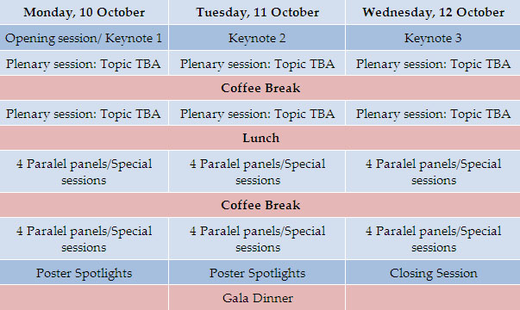
If you would like to submit a proposal, please fill in the form in the next page and e-mail it to matej.kobav@fe.uni-lj.si, no later than March 30th, 2016. Include relevant personal data or links to it.
A reply to the proposal will be send by the TP committee before April 30th, 2016.

Sincerely,
dr. Matej B. Kobav
ISGT Europe 2016 Secretary

Industry or project session proposal – IEEE ISGT EUROPE 2016

Session title:
Type of session: (Formal or informal)
Proposed by/main speaker: | Name
 | Affiliation
 | Contact Email
 | Link to personal web page or CV page
Invited Speaker 1: | Name
 | Affiliation
 | Contact Email
 | Link to personal web page or CV page
Invited Speaker 2: | Name
 | Affiliation
 | Contact Email
 | Link to personal web page or CV page
Invited Speaker 3: | Name
 | Affiliation
 | Contact Email
 | Link to personal web page or CV page

Abstract:
A brief description of the area of the session and the motivation for having such a session.
Please include a short description of the proposed tutorial in no more than 500 words.
Please state if you have already organized a session on the same or similar topic in a previous IEEE PES conference or Power Systems similar one.

Additional information
You can include attached to the email, any other information you find valuable about the proposed session, and your CV.

