Call for Technical session

ISGT Europe 2016 – Ljubljana, Slovenia

On behalf of the Technical Program Committee of the IEEE ISGT EUROPE 2016 Conference (Monday, 10th – Wednesday, 12th October 2016) we would like to invite Smart Grids experts, to submit proposals for technical session on Smart Grids topics.
Technical sessions will we organised as special sessions of the conference
A limited number of invited technical sessions will be held as part of the conference. Papers in each invited technical session must undergo the same review process as regular technical papers, and if accepted will be indexed by IEEE Xplore.
Typically, a session takes a 1:30 hour time slot including questions to the lecturers.
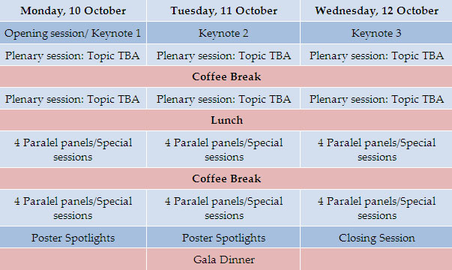
If you would like to submit a proposal, please fill in the form in the next page and e-mail it to matej.kobav@fe.uni-lj.si, no later than March 30th, 2016. Include relevant personal data or links to it.
A reply to the proposal will be send by the TP committee before April 30th, 2016.

Sincerely,
dr. Matej B. Kobav
ISGT Europe 2016 Secretary

Technical session proposal – IEEE ISGT EUROPE 2016

Session title:
Proposed by/main speaker: | Name
 | Affiliation
 | Contact Email
 | Link to personal web page or CV page
Invited Speaker 1: | Name
 | Affiliation
 | Contact Email
 | Link to personal web page or CV page
Invited Speaker 2: | Name
 | Affiliation
 | Contact Email
 | Link to personal web page or CV page
Invited Speaker 3: | Name
 | Affiliation
 | Contact Email
 | Link to personal web page or CV page

Abstract:
A brief description of the area of the session and the motivation for having such a session.
Please include a short description of the proposed tutorial in no more than 500 words.
Please state if you have already organized a session on the same or similar topic in a previous IEEE PES conference or Power Systems similar one.

Additional information
You can include attached to the email, any other information you find valuable about the proposed session, and your CV.

