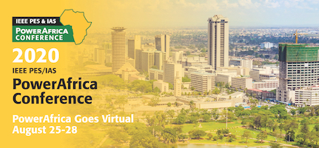
Greetings from the 2020 IEEE PowerAfrica Committee,

Are you willing to Volunteer your time and expertise as a reviewer to make PowerAfrica 2020 a success by serving as a member of The Technical Program Review Committee
Applications are invited from academics, experts and specialists in the Thematic areas below.
1. Smart Grid, Microgrid, Metering Design and Cyber Security, FACTS
2. Renewable Energy Resources, Grid Integration Technologies, Electric Transportation
3. Electrical Safety, Power System Protection & Standards
4. Power Converter Topologies, Electric Drives, Modeling & Control
5. Power System Planning, Energy Efficiency, Power Projects, Power Engineering Education
6. Electric machines, drive systems and topologies
7. Signals & Systems

The fair and timely review process done by the reviewers is the key factor for the selection of high-quality papers for presentation and publication. We greatly appreciate reviewers for their contribution to the success of the conference. If you have previously participated as a reviewer we encourage you to register again this year. We also invite new reviewers to join. All reviewers will be guided by the respective Track Chairs on the process.

Papers have been/will be submitted directly to each track via the EasyChair online submission system. As with the submission of papers, reviewing of the papers will be done online on EasyChair.
If you agree to review, please expect to receive 2 or 3 papers by June 20th 2020. You should be available to complete the reviews to abide by the notification schedules.

We do hope that you will find the time to assist us with this important review process, and consider submitting a paper yourself. Please, circulate this message to your colleagues whom you think would be able and willing to contribute.
Visit the Call for Reviewers page

Submit your application to become a reviewer

Regards,
Technical Program Committee Chairs, 2020 IEEE PES/IAS PowerAfrica Conference
Email: tpc-chairs@ieee-powerafrica.org

