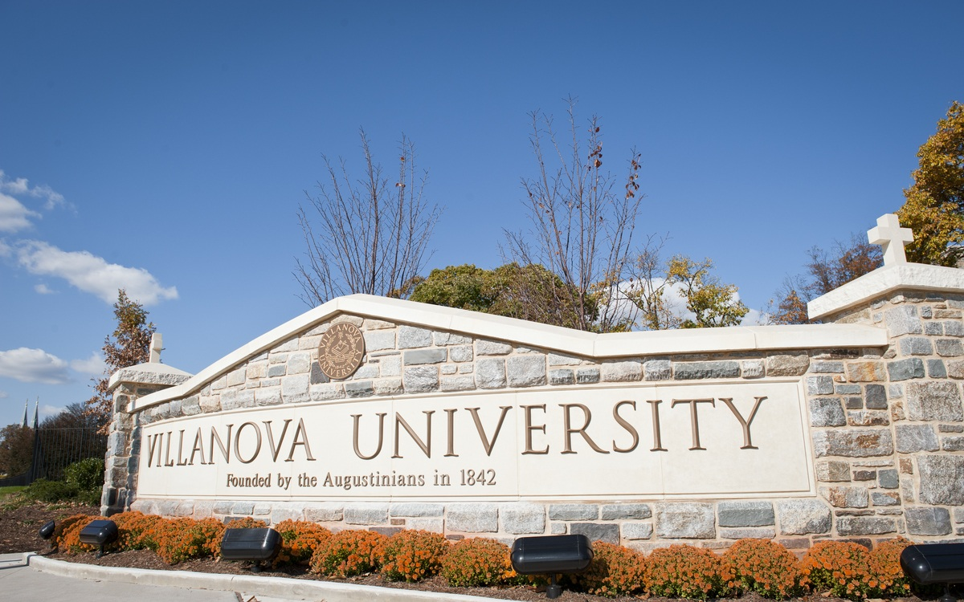

Spring 2024 Joint Region 2 & Region 1

Student Activities Conference

Villanova University
Villanova, Pennsylvania
April 5-7, 2024
Sponsorship Packet

Villanova University Sign, Lancaster and Ithan Avenues (Credit: © Villanova University)
Conference Level Sponsorship

The Spring 2024 Region 2 and Region 1 Joint Student Activities Conference is primarily a one-day event (April 6, 2024), hosting over 30 university IEEE student branches from universities in New England and the mid-Atlantic Region (IEEE Region 1 and 2). With various activities showcasing the student branches' technical and leadership capabilities, there are ample opportunities to reach various students. Villanova’s University’s Institute for Electrical and Electronic Engineers (IEEE) Student Branch seeks sponsorships for the overall conference, specific activities, and social events.

Double Diamond – $4,000+
Sponsoring the Conference through the Double Diamond tier includes:
- Company name displayed at the conference banquet
- Company name displayed on banner
- 20min informational Session about your company
- Table at the Company Expo
- Recognition at all competitions and events
- Full-page advertisement in the conference pamphlet

Diamond – $3,000+
Sponsoring the Conference through the Dimond Tier includes:
- Company name displayed on conference banner
- 20min informational Session about your company
- Table at the Company Expo
- Recognition at all competitions and events
- Full-page advertisement in the conference pamphlet

Platinum – $2,000+
Sponsoring the Conference through the Platinum Tier includes:
- Company name displayed on conference banner
- 20 min informational Session about your company
- Table at the Company Expo
- Recognition at all competitions and events
- Half-page advertisement in the conference pamphlet

Conference Level Sponsorship (con’t)

Gold – $1,000+
Sponsoring the Conference through the Gold Tier includes:
- 20min informational Session about your company
- Table at the Company Expo
- Recognition at all competitions and events
- Quarter-page advertisement in the conference pamphlet

Silver – $500+
Sponsoring the Conference through the Silver Tier includes:
- Table at the Company Expo
- Recognition at all competitions and events
- Eighth-page advertisement in the conference pamphlet

Bronze – $250+
Sponsoring the Conference through Bronze Tier includes:
- Name listed in the conference pamphlet

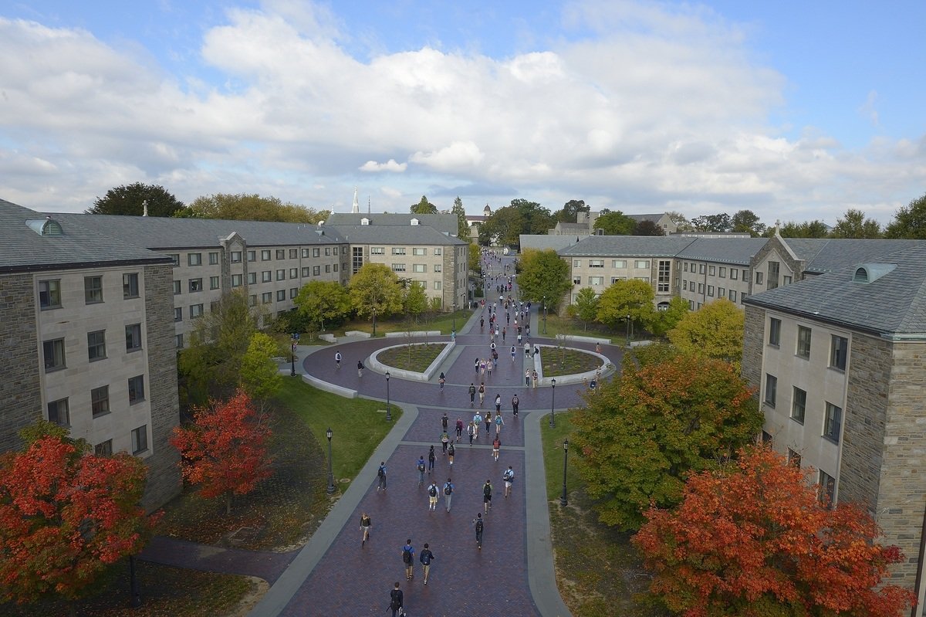

Villanova University Campus (Credit: © Villanova University)

Event Level Sponsorships

Saturday Banquet Sponsorships – $500+
Saturday’s evening banquet will recognize the winners of each competition and a keynote speaker. Over 200 attendees are expected.
  - Logo on display during the banquet
  - Special recognition at the banquet
  - 7 Sponsorships Available

Saturday Lunch Sponsorships – $250+
Saturday’s lunch is held during the events at the Villanova University’s campus. Over 200 participants are expected to attend.
  - Logo on display during Lunch
  - 7 Sponsorships Available

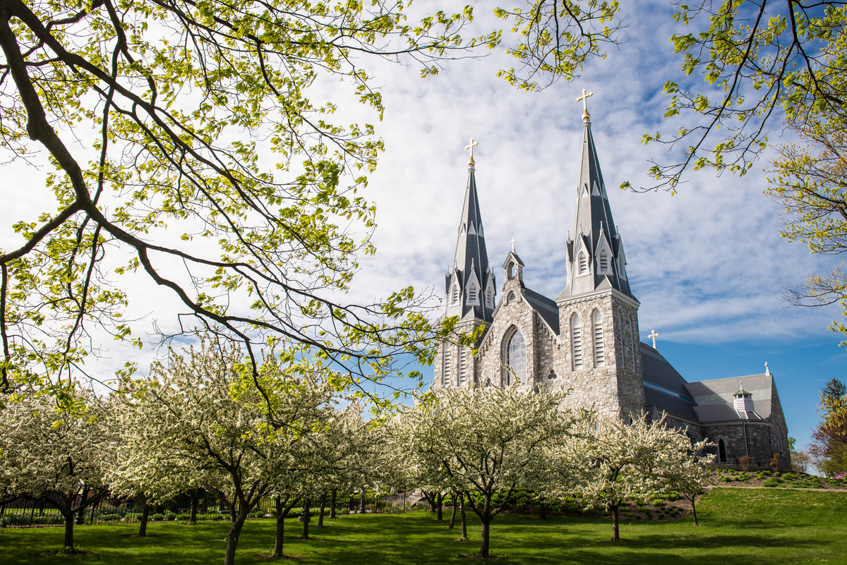

St. Thomas of Villanova Church (Credit: © Villanova University)

Competition Level Sponsorships

Micro-Mouse Competition – $250+
The Micro Mouse competition is one of IEEE’s most popular and well- known events. Students are tasked with creating an autonomous maze solving robot. They are scored on how quickly their robot is able to complete the maze provided.
  - Company name on the competition banner
  - 6 Sponsorships Available

Sumo Bot Competition – $250+
The Sumo Bot Competition has each team design, build, and code their own robot. This robot acts autonomously to push the enemy robot outside of the arena in a sumo-style battle.
  - Company name on the competition banner
  - 6 Sponsorships Available

Ethics Competition – $250+
IEEE Student Ethics Competitions (SECs) are sponsored by the IEEE Ethics and Member Conduct Committee (EMCC).and include a presentation and defense of a case analysis by teams of students.
  - Company name on the competition banner
  - 6 Sponsorships Available

Brown Bag Competition – $250+
his event tasks participants with completing a series of circuits challenges. Teams of one to four will work in a circuits laboratory environment using nothing but their electronics knowledge (and provided datasheets). Some tasks might include combining resistors to get a specific total resistance, building logic gates out of transistors, and implementing digital counters.
  - Company name on the competition banner
  - 6 Sponsorships Available

Supplies
If you would like to provide donations in the form of supplies for the events, please email: jfazio3@villanova.edu .

Sponsorship Overview
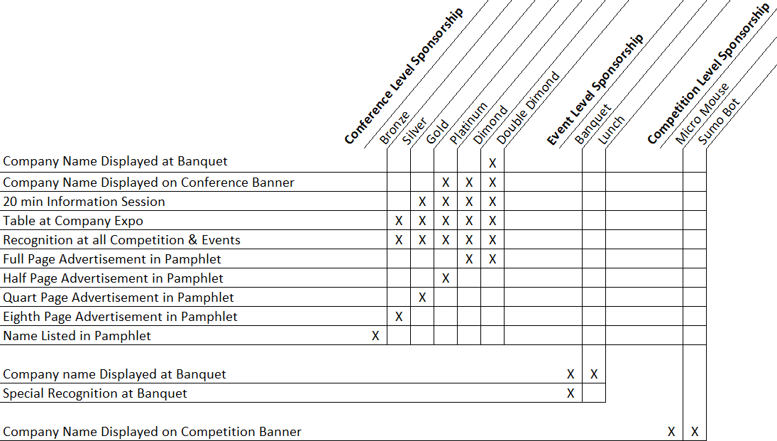

Registration: Please mail your sponsorship form with a check or money order payable to IEEE Region 2, to the address on the form (next page). We cannot accept credit card payments.

For more information regarding sponsorship details, do not hesitate to contact the Villanova University IEEE Student Branch President by email at jfazio3@villanova.edu

Deadline: 1 March 2024

Mail the sponsorship materials using the form and address on the next page.

Spring 2024 IEEE Region 2 and 1 Joint Student Activities Conference Sponsorship Form

Please complete and return this form with a check payable to: IEEE Region 2

Mail this sponsorship form to:

Barbara Frantom, IEEE Dayton Section Treasurer
1242 Rustic Creek Dr.
Centerville OH 45458

Company Name/ Individual Name:
Address:

Point of Contact:
Telephone Number:
Email Address:

Please Note: Once received, all sponsorships are final and non-refundable.

Deadline: 1 March 2024

